An Automatic Emulation System for Thermal Energy Harvesting

Marcelo Miranda Camboin
Department of Electrical Engineering
Federal University of Paraíba
João Pessoa, PB Brazil
marcelo.camboim@cear.ufpb.br
Orlando Baiocchi
School of Engineering and Technology
University of Washington Tacoma
Tacoma, WA USA
baiocchi@uw.edu
Andréa Willa Rodrigues Villarim
Graduation Program of Electrical Engineering
Federal University of Paraíba
João Pessoa, PB Brazil
andrea.villarim@cear.ufpb.br
Cleonilson Protasio de Souza
Department of Electrical Engineering
Federal University of Paraíba
João Pessoa, PB Brazil
protasio@cear.ufpb.br

Abstract—Thermoelectricity energy harvesting based on thermoelectric generator (TEG) are having a prominent role in energy harvesting solutions since they have dramatically grown recently due to prevalence of thermal gradient ∆T presented in different environments, not only natural but also industrial environments. However, to prove that a given environment is adequate to generate energy is a hard task. In order to early evaluate the potential of given environment to get enough thermal energy to be converted to electric energy, in this paper we present an automatic emulation system of thermal energy to evaluate the potential of use of any thermal source in a simple way. Experimental results show that the platform can emulate any thermal gradient pattern, apply this pattern on a TEG and measuring the actual electric energy generated by the TEG. An example of application is described, and its results are shown. The example is of an experiment to harvest energy from tree trunks.
Keywords— energy harvesting, thermoelectric generator, thermal emulation platform

Introduction
Nowadays, the increasing use and the high demand for low and ultralow power electronic devices are boosting studies to avoid batteries aiming to design self-sustainable, autonomous and environment friendly electronic systems. Batteries have been played an important role for decades both for small-scale energy storage and for high-scale energy storage, but their use implies as disadvantage the fixed costs of replacement or of recharging [1] and, even worse, since all parts of a battery are made of pure or compound chemical material where some may be toxic, environmentally unfriendly, or not sustainable. As a result, if used-up batteries are not properly disposed, then their toxic material can leak and contaminate the soil and water and some of the materials can accumulate into the surrounding environment [1][2][3]. Then, avoiding the use of batteries is important for environmental issues and maintenance cost reduction.
Autonomous, environmental friendly and battery-free electronic devices are particularly important to environmental monitoring system where the so-called Environmental Sensor Network (ESN) has being attracted considerable research interests in recent years [4] since this network can be applied in pollution monitoring, meteorological conditions measurement (e.g. temperature, wind velocity, solar radiation, atmospheric precipitation etc.), forest fire, seismic activity, etc. [5].
ESN is a particular kind of Wireless Sensor Networks (WSNs), which are a technology for large-scale monitoring, providing sensor measurements at high temporal and spatial resolution [6] [7] [8]. In general, ESN and WSNs are composed of a large number of low cost and low power sensor nodes communicating at distance and sink nodes.
A critical characteristic of ESN/WSN is its lifetime that is defined as the round number when the first node runs out of energy [9]. In order to maximize the lifetime, it is required either to use high-capacity batteries, consequently, bigger battery size (increase the dangerous for natural environment), or to design low-power node circuits. These approaches could prolong the ESN/WSN lifetime as far as possible, but it will be always finite, that is, only as long as the battery lasts. However, in order to an ESN/WSN to operate in an energy autonomous, maintenance-free manner and with infinite lifetime (taking only the battery capacity in consideration); it needs to be powered from environmental energy [10]. In this context is that has emerged the energy harvesting.
Energy Harvesting is defined as the practice of collecting, accumulation and storage of energy from surrounding environmental sources where the energy source can be from available sources such as solar, light, temperature, motion or electromagnetic waves, etc. [11][12][13][14]. Energy harvesting devices are potentially attractive as an alternative for batteries in ESN/WSN or to prolong battery life by charging rechargeable batteries [15].
Among several energy harvesting solutions, the thermoelectricity [11] [16] based ones have dramatically grown recently due to prevalence of thermal gradient ∆T presented in different environments, not only natural but also industrial environments (for instance, boiler plants). The main contributor to thermoelectricity energy harvesting solutions is the thermoelectric generator (TEG) that is a device that convert temperature differences directly into electrical energy and vice-versa and are made of semiconductors connected electrically in series, thermally in parallel and disposed between two plates of ceramic [17] [18] [19], as shown in Figure 1.
In a TEG, the higher is the temperature gradient ∆T on the TEG sides, the higher is the obtained electric voltage ∆V. The relation is given by the equation ∆V=α·∆T, where α is the Seebeck coefficient and ∆T = TH – TC ≠ 0 on its hot and cold plates for conversion takes place [19].
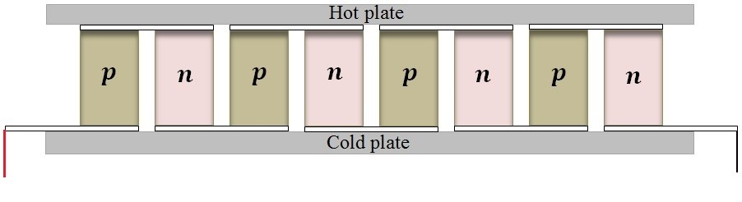
- Internal view of a thermoelectric generator (TEG). Source: [19].
A very interesting application of TEG in ESN/WSN is the Smart Tree [20] that potentially can be used in a fire forest monitoring, precision agriculture, tree life monitoring and others. The concept of the Smart Tree is that its electronic part is powered by electrical energy obtained by the conversion by a TEG of the temperature gradients presented in an internal spot of the tree trunk and its external temperature (bark temperature) [20]. An interesting point that worth to be highlight is that the natural temperature control of the trees tries to maintain that gradient and, mainly, there exists ΔT either at daylight (+ΔT) or during the night (-ΔT) with an inversion at twilight, showing to be possible to harvest thermal energy all day long [20].
It was proved that, as a tree trunk is a living organism, the temperature gradient ΔT between any annual ring and the external temperature can be slightly constant or presents slow increment or decrement as the external temperature varies, as shown in Figure 2. The explanation to this is that trees try to remain in a comfort zone despite its external temperature regulating their temperature.
Figure 4 shows the experimental results when the temperature was measured in three different depths of a tree: 100mm, 75mm, and 50mm and the external temperature [2]. As can be noted, the deeper the depth, bigger is ΔT. This result indicates that the depth to install the Energy Harvesting transducer can be chosen accordingly to the voltage level that is required. An interesting point that worth to be highlight is that either at daylight or during the night, ΔT exists with an inversion at 18:00 (6pm) and at 6:00 (6am), the local twilight hours, showing to be possible to harvest thermal energy all day long.
A possible implementation of the tree trunk Energy Harvesting transducer is shown in Figure 5.
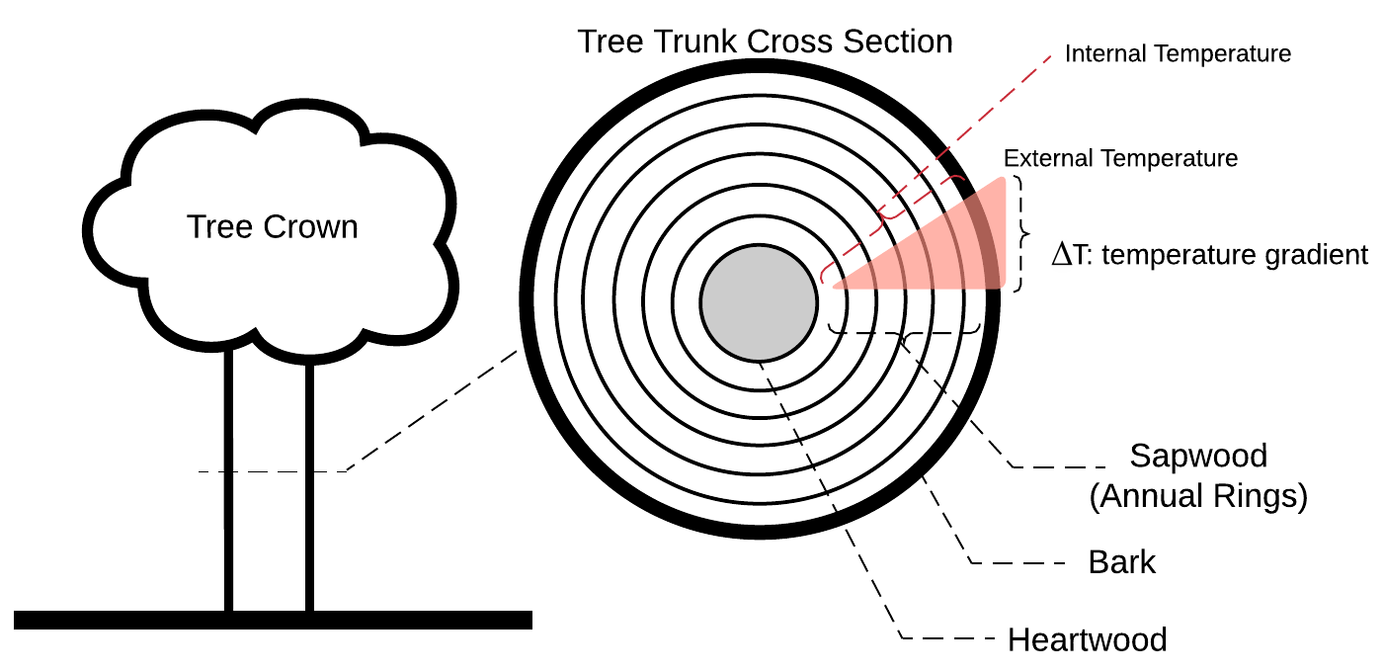
- Temperature gradient comes from different annual rings related to external temperature. Source: [20].
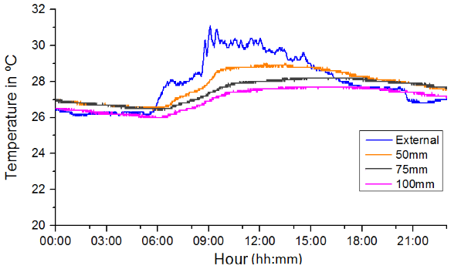
- Temperature measurement in three depths of a tree: 100mm, 75mm, and 50mm and the external temperature. Source: [20].
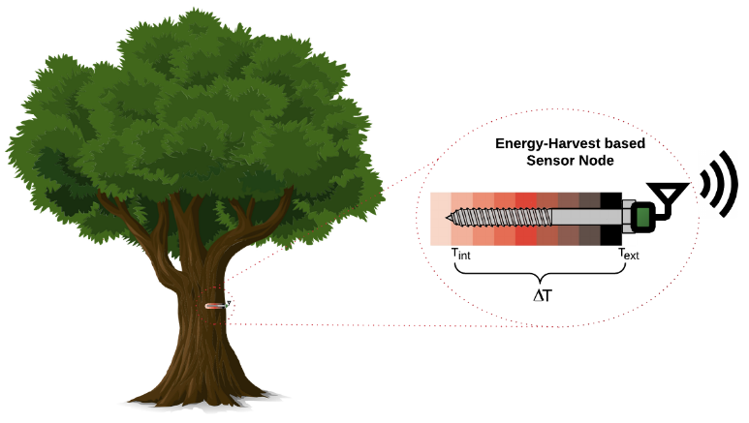
- A possible implementation of the tree trunk Energy Harvesting transducer. Source: [1].
Taking in consideration that several new propositions of thermal energy harvesting systems like the Smart Tree are going to be devised and that the first and more important fact to this development is the previous evaluate the potential of the thermal energy to be converted to electric energy before the development itself, in this paper we present an automatic emulation system of thermal energy to allow energy harvesting developers to evaluate the potential of use of any thermal source provided that the temperature gradient ΔT pattern from this source is available. In this way, the platform can emulate any ΔT pattern, apply this pattern on a TEG and measuring the actual electric energy generated by the TEG.

Temperature Emulation Platform

An automatic platform for thermoelectric generator testing was proposed in [19] that is capable to apply specific thermal cycling pattern in order to evaluate thermoelectric generators (TEGs). The platform consists of a symmetrical physical structure formed by fan cooler, heatsink and thermoelectric modules to heat or cool a central thermoelectric-module under test. A LabVIEW®-based control system was designed to control entirely the platform and the measurement system based on a DAQ system (namely, PCIe-6321 da National Instruments) is used to interface the control system to the platform as shown in Figure 5.
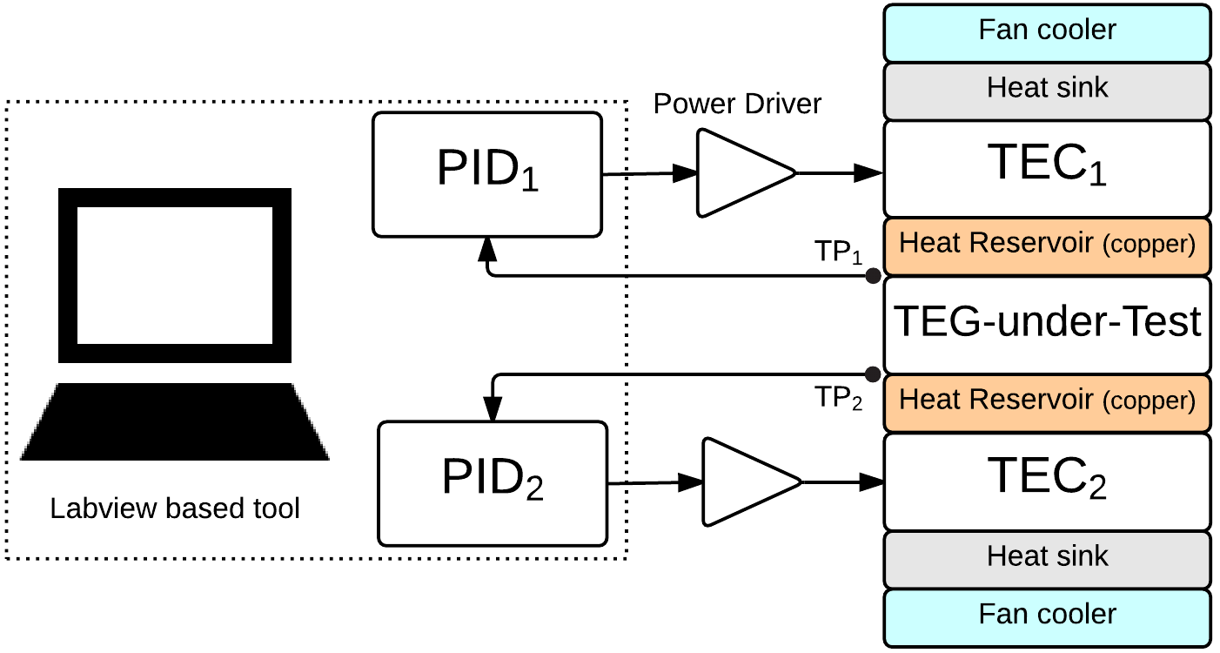
- The automatic platform for thermoelectric generator testing. Source: [19].
As can be seen in Figure 5, the TEG-under-Test is spotted between two similar thermal structures where each one is composed of a heat reservoir, a thermoelectric cooler (TEC), a heat sink and a fan cooler.
The TEC is applied an input voltage controlled by a PID, through a power driver, that has as feedback input the temperature achieved by the TEC. The set of heat sink/fan cooler is needed to path the generated heat out or in the platform, according to the requested TEC temperature on the face contacting the TEG-under-Test, that is, if this temperature is to be cold, the heatsink/fan cooler set is turned in a way to get heat from the TEC to out the platform and vice-versa, as shown in Figure 6.
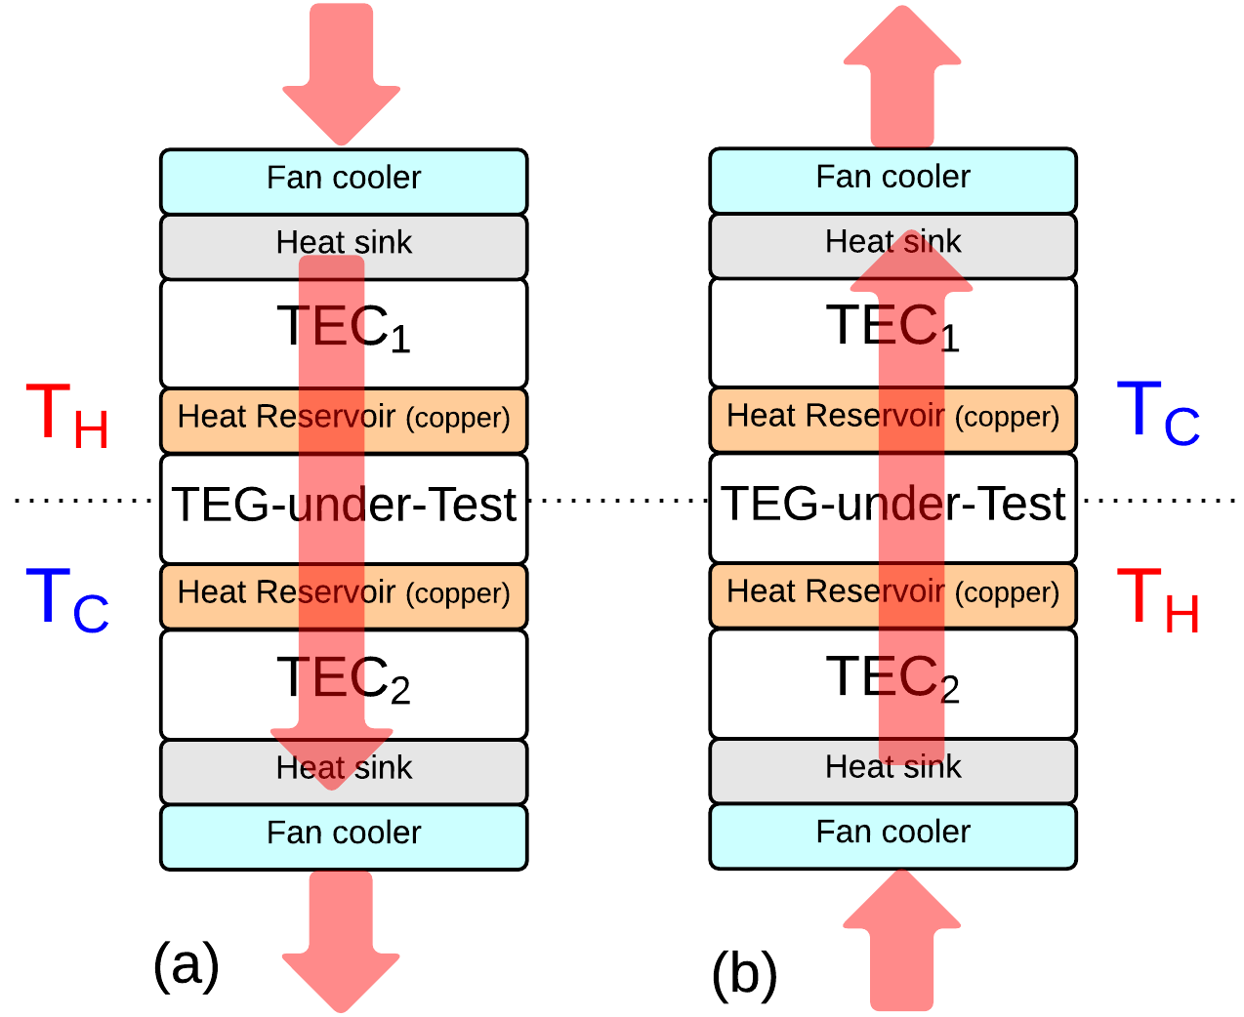
- The heat pathway throughout the platform. Source: [19].
The automatic platform for thermoelectric generator testing is capable to generate temperature as high as 40ºC, on each side, and temperature gradient about to 20ºC.

Temperature Emulation Platform Virtual Instrument
The automatic platform is driven by a Virtual Instrument (VI) developed in LabVIEW® where, as shown in Figure 8, the user has to gather the measured temperature data, composed of two arrays of temperature data (namely, T₁(t) and T₂(t)) and the related timestamp array, in a spreadsheet that is read by the VI. After, the VI emulates and applies ΔT = T1 (t) - T2 (t) on the TEG that generates v (t). The VI also display the generated v (t) as well as ΔT (t), T1 (t) and T2 (t).
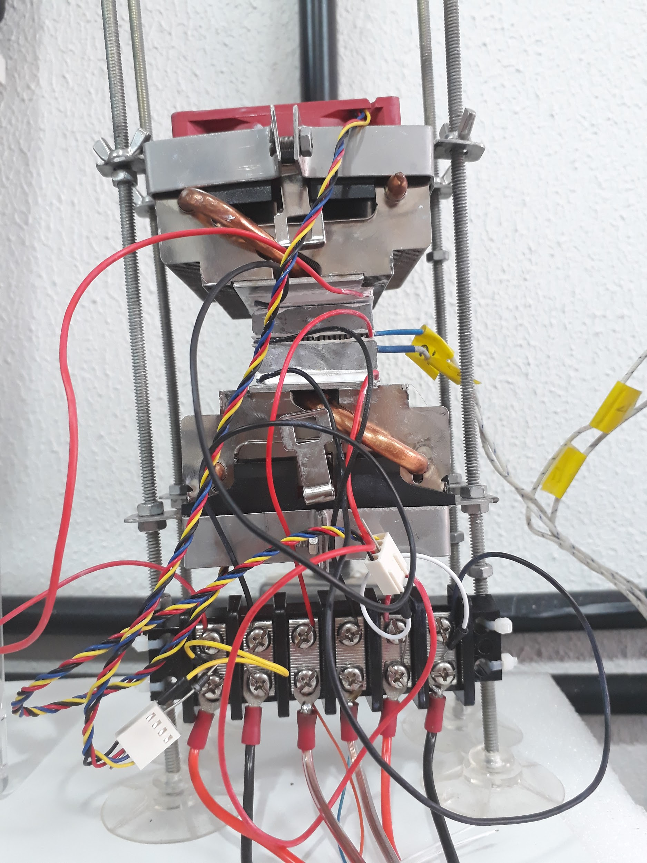
- A photograph of the automatic platform for thermoelectric generator testing.
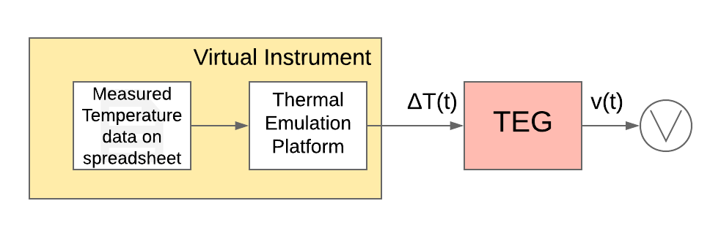
- A complete view of the proposed thermoelectric emulation system.
An algorithm to show the VI operation is described below.
Algorithm 1: Virtual Instrument
Input: temperature T₁(t) array, temperature T₂(t) array, timestamp t
Output: Generated voltage v (t), regulated voltage v_{r}(t).
1: {Step 1} Insert a text file with the actual data to be emulated
2: {Step 2} Read the file
3: while there are lines to be read do
4: {Step 3} Read line
5: {Step 4} PID control will match the emulated temperature with the actual temperature
6: {Step 5} Wait one second
7: if absolute value of (emulated internal temperature – actual internal temperature) <= 0.3 and absolute value of (emulated external temperature – actual external temperature <= 0.3) then
8: {Step 6} Save output data
9: break
10: else
11: {Step 6} Go back to Step 5
12: end if
13: end while

After the start, the VI reads sequentially the values of T₁ (t), T₂ (t) and the timestamp t, generate T₁ (t) and T₂ (t). As generally thermal time constant is very long, we noted that has no reason to wait the time interval between two points of temperature (for example: T₁ (t0) and T₁ (t0 + t)). In this way, when the generated temperature is achieved within an error of ±0.3°C, the VI ends up this step and begins to generate the next temperature value. When the V_{i} ends up an emulation, the VI store the current data. Despite that, the VI runs in a 1 second acquisition time.
That feature concerning the time is important to save emulation time because, for instance, the smart tree experiment lasts for 4 days and the emulation time was about ??? hours.
This VI will continue until all the data rows have been read and emulated.

Experimental Results
To prove the effectiveness of the proposed automatic emulation system of thermal energy, the smart tree data were being used. These data are comprised of temperature measured at 100mm inside the tree (internal) and the temperature on the bark (external) and Figure 9 shows the particular pierce of data used to get the experimental results in this paper. The data consist of values from 6:00 of January 19th to 6:00 of January 20th as shown in Figure 9. Observing this figure, it is possible to observe a clear inversion of the external temperature with respect to the internal temperature at about 3 am. In addition, it is noted that in this section the temperature differences are significant, having ΔT (external temperature minus internal temperature) peaks of 4.69°C and -2.43°C.
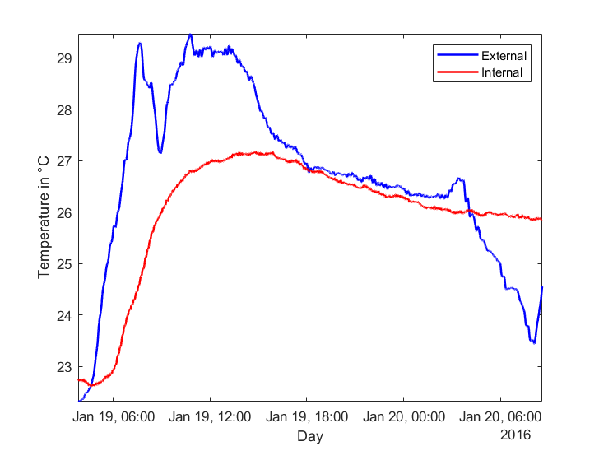
- Tree temperature data from 6:00 of January 19th to 6:00 of January 20th.
Using the thermal platform, the measured thermal curves are then emulated. Figure 10 shows the emulated internal temperature and the Figure 11 shows the external emulated temperature.
From Figures 10 and 11, we can observe that the thermal platform follows precisely the temperature curves along the day and, analyzing the errors, a root means square error (RMSE) of 0.1042 was obtained from the external temperature and the RMSE of the internal temperature was 0.0955.
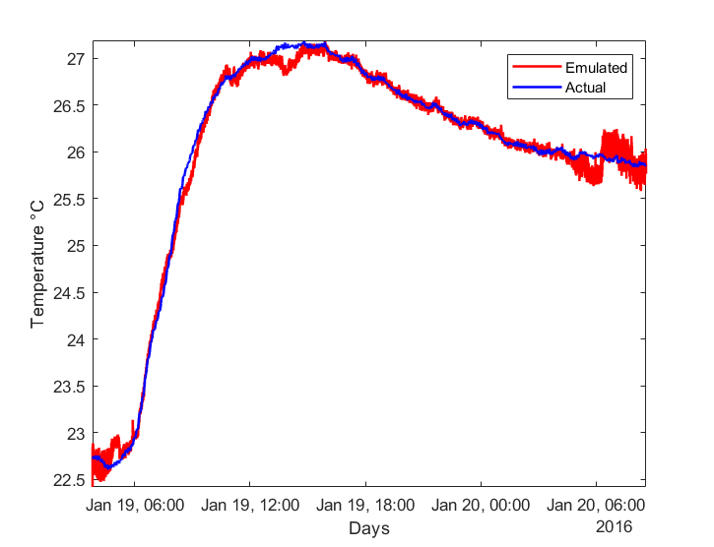
- Tree temperature: emulated internal temperature.
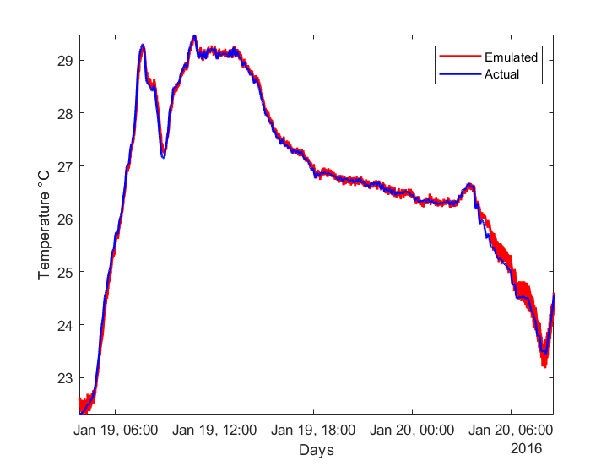
- Tree temperature: emulated external temperature.
As show in Section III, the emulated thermal gradient ΔT curve was applied directly onto a TEG, which establishing a temperature gradient between the TEG upper and bottom faces. The generated TEG voltage curve according to the emulated ΔT is shown in Figure 12.
  - Thermal Energy Regulation
The Peltier cell (TEG-under Test) generated voltage was applied directly into a voltage regulator where the minimum voltage to work is 20mV. This voltage regulator is based on the LTC3108 IC from Linear Technology that is an integrated DC/DC converter (synchronous Boost converter) specifically for harvesting and managing surplus energy from low input voltage sources such as TEGs. The LTC3108 works on selectable output voltage of 2.35V, 3.3V, 4.1V or 5V and uses a control technique to achieve high efficiency and low-power consumption. The LTC3108 utilizes an external step-up transformer and a small coupling capacitor to form a resonant step-up oscillator as shown in Figure 13 allowing to boost input voltages as low as 20 mV.
A charge control circuit is used to control the current that charges the output voltage on V_{out}. The IC starts its operation when it is checked that the V_{aux} output has reached the proper level. If the output voltage V_{out} is set above the selected threshold, the charging current is turned off, but if V_{out} drops below that level and Vaux is greater than its minimum value, the charging current is enabled again, and the converter recharges the output capacitor. Another output pin (V_{STORE}) also can be used to charge a large capacitor. When V_{out} reaches regulation, the V_{STORE} can charge up and the element connected to this pin can be used to power the load in cases when the input source is lost, or it cannot provide enough current to charge the main output voltage. The LTC3108 has an internal operation that monitors the output voltage and that allows it to operate consuming low currents, which is an advantage is energy harvesting applications. The schematic for the use of this IC can be seen in Figure 13.
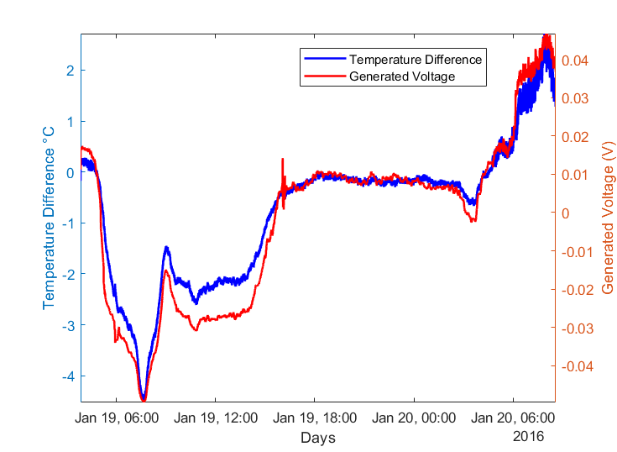
- Smart Tree: Generated Voltage.

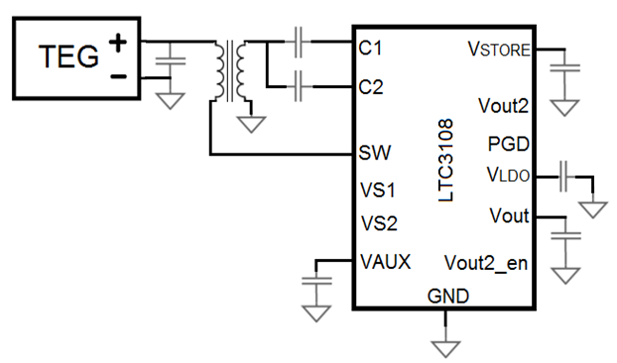
- Energy conditioning circuit based on LTC3108.
  - Regulated Voltage
The generated voltage shown in Figure 12 was applied to the energy conditioning circuit based on LTC3108, shown in Figure 13, and it was capable to obtain a regulated voltage of 3.3V from the TEG-under Test as can be observed in Figure 14.
From Figure 14, we can observe that in great part of the day, the tree was possible to effectively generate a potential thermal gradient ΔT to enable the conditioning circuit to regulate a voltage to power, for instance, a sensor node, in particular between 5:50 and 14:24, which it was possible to power a voltage regulator during 8 hours and 34 minutes, that corresponds to over than one-thirds of the day.

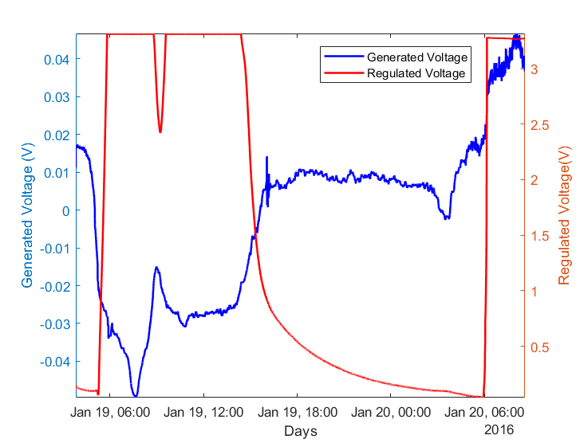
- Regulated Voltage

Conclusions
It was introduced a way to early evaluate the potential of given environment for harvesting thermal energy. The way is based on an automatic emulation platform that can emulate any thermal gradient pattern, apply this pattern on a TEG and measuring the actual electric energy generated by the TEG. With the proposed way, any thermal gradient pattern from a particular environment can be emulated and its potential to energy harvesting can be assessed. In addition, a regulation circuit that works from voltage as low as 20mV was shown that prove the capacity to harvest and store energy from the described proof-of-concept: harvesting energy from a tree trunk.

References
- Souza, C. P. and Baiocchi, O. Energy Resources in Agriculture and Forestry: How to be Prepared for the Internet of Things (IoT) Revolution, Energy Systems and Environment, 2018. IntechOpen, DOI: 10.5772/intechopen.74940.
- D. Linden and T. B. Reddy, Handbook of batteries, no. 3d. 2001.
- N. Kularatna, “Rechargeable battery technologies,” in Energy Storage Devices for Electronic Systems, Elsevier, 2015, pp. 29–61.
- Shi Lan, Miao Qilong, and Jinglin Du. Architecture of wireless sensor networks for environmental monitoring. In Education Technology and Training, 2008. and 2008 International Workshop on Geoscience and Remote Sensing. ETT and GRS 2008. International Workshop on, volume 1, pages 579–582, Dec 2008.
- A. Nayak and I. Stojmenovic. Wireless Sensor and Actuator Networks. John Wiley & Sons, New Jersey, USA, 2010.
- P. Corke, T. Wark, R. Jurdak, Wen Hu, P. Valencia, and D. Moore. Environmental wireless sensor networks. Proceedings of the IEEE, 98(11):1903–1917, Nov 2010.
- N. M. Freris, H. Kowshik, and P.R. Kumar. Fundamentals of large sensor networks: Connectivity, capacity, clocks, and computation. Proceedings of the IEEE, 98(11):1828–1846, Nov 2010.
- I. F. Akyildiz, Weilian Su, Y. Sankarasubramaniam, and E. Cayirci. A survey on sensor networks. Communications Magazine, IEEE, 40(8):102–114, Aug 2002.
- Ying Liang and Yongxin Feng. An energy-aware routing algorithm for heterogeneous wireless sensor networks. In Hybrid Intelligent Systems, 2009. HIS ’09. Ninth International Conference on, volume 2, pages 275–278, Aug 2009.
- Sangkil Kim, R. Vyas, J. Bito, K. Niotaki, A. Collado, A. Georgiadis, and M.M. Tentzeris. Ambient RF energy-harvesting technologies for self-sustainable standalone wireless sensor platforms. Proceedings of the IEEE, 102(11):1649–1666, Nov 2014.
- Adnan Harb. Energy harvesting: State-of-the-art. Renewable Energy, 36(10):2641–2654, 2011.
- U. Baroudi, A. Qureshi, S. Mekid, and A. Bouhraoua. Radio frequency energy harvesting characterization: An experimental study. In Trust, Security and Privacy in Computing and Communications (TrustCom), 2012 IEEE 11th International Conference on, pages 1976–1981, June 2012.
- T. O. Moraes Junior, Y. P. M. Rodriguez, and C. P. Souza. Experimental results on magnetic cores for magnetic induction-based energy harvesting. In 19th IMEKO TC4 Symposium and 17th IWADC Workshop Advances in Instrumentation and Sensors Interoperability, pages 625–630, July 2013.
- M. P. Santos, D. A. Vieira, Y. P. M. Rodriguez, C. Protasio de Souza, T. O. De Moraes, and R. C. S. Freire. Energy harvesting using magnetic induction considering different core materials. In Instrumentation and Measurement Technology Conference (I2MTC) Proceedings, 2014 IEEE International, pages 942–944, May 2014.
- M. Ali, L. Albasha, and N. Qaddoumi. RF energy harvesting for autonomous wireless sensor networks. In Design Technology of Integrated Systems in Nanoscale Era (DTIS), 2013 8th International Conference on, pages 78–81, March 2013.
- Y. K. Ramadass and A.P. Chandrakasan. A battery-less thermoelectric energy harvesting interface circuit with 35 mv startup voltage. Solid-State Circuits, IEEE Journal of, 46(1):333–341, Jan 2011.
- B. I. Ismail, W. H. Ahmed, “Thermoelectric Power Generator Using Waste-Heat Energy as an Alternative Green Technology”, Recent Patents on Electrical Engineering, v. 2, pp. 27-39, 2009.
- P. Dziurdzia, “Modelling and Simulation of Thermoelectric Energy Harvesting Processes,” Sustainable Energy Harvesting Technologies – Past, Present and Future, pp. 109 – 128, 2011.
- J. C. de Cerqueira Véras, D. Alburquerque Vieira, E. C. S. Melo and C. Protásio de Souza, "An automatic thermal cycling based test platform for thermoelectric generator testing," 2015 IEEE International Instrumentation and Measurement Technology Conference (I2MTC) Proceedings, Pisa, 2015, pp. 1949-1953. doi: 10.1109/I2MTC.2015.7151580.
- C. P. Souza et al., “On Harvesting Energy from Tree Trunks for Environmental Monitoring,” Int. J. Distrib. Sens. Networks, vol. 12, no. 6, p. 9383765, Jun. 2016.
- R. Nicole, “Title of paper with only first word capitalized,” J. Name Stand. Abbrev., in press.
- Y. Yorozu, M. Hirano, K. Oka, and Y. Tagawa, “Electron spectroscopy studies on magneto-optical media and plastic substrate interface,” IEEE Transl. J. Magn. Japan, vol. 2, pp. 740–741, August 1987 [Digests 9th Annual Conf. Magnetics Japan, p. 301, 1982].
- M. Young, The Technical Writer’s Handbook. Mill Valley, CA: University Science, 1989.

.

